**Jason Halverson**

<https://www.linkedin.com/in/aboutjasonhalverson/> ● [halv.jason@gmail.com](mailto:halv.jason@gmail.com)

Date: Saturday, June 23rd, 2018

To: Perez, Ben ; Dockstader, Ryan

Cc: Rex N. Fisher

From: Jason Halverson

Subject: 9.8 Assignment: Strategic Planning

* Proposed Plan:

We propose to build an inventory tracking system for a local company that has an open bid to contract out this system.

* Project Mission:

We will obtain the specifications from the company and conduct research with similar end users to design an appropriate system. We will then prototype and build an effective program for tracking inventory. This will include a system database, a user interface and a display format.

* Project Plan:

1. Obtain specifications from company.
2. Conduct research to determine options budgets and timelines
3. Present our recommended approach with cost and timeline estimates
4. Wireframe and prototype the design
5. Provide end user with final design and cost (in development hours)

* Team Roles and Workload Distribution:
* **Team Lead** – Will oversee pushing the project. The lead will push the time line to ensure the completion of the project is delivered on time if not earlier. In order to accomplish this he / she will ensure each team member follows the work flow stated below for stream lined efficiency. If one team member does not accomplish his / her task on time the team lead will request a deadline and if not finished by them parcel out the work amongst the team.

* **Research:** This team member will be responsible for obtaining all facts, figures and statistics. The researcher will provide the copy writer with credible (Preferably peer reviewed) sources. This is also a role that will handle obtaining statistics and preferences from end users and or process owners. If there is a need for any type of information this will be provided by the researcher.
* **Document Designer:** This team member will handle all document design and graphics completion. They will receive the content from the copy writer and place this in an appealing document style. All graphics will also be designed and or obtained by the document designer. The document designer will provide the finished copy to the team for approval before it is submitted by the team lead at the end of the week.
* **Copy writer:** This position will be filled by all three team members. This will be the actual writing of the text for weekly submissions. The information will be provided by the researcher and together the team will write out a cohesive document that will be provided to the document designer. All grammar, phrasing and word flow will be provided.
* Project Calendar:
  + Proposal 6/23 – 6/30
  + Draft 7/1 – 7/7
  + Final 7/8 – 7/14

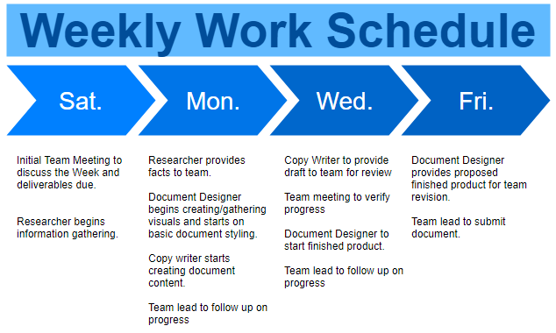

* Collaboration Methods:
  + Weekly communication will occur over email for ease of tracking. Daily communiqué will use Google Hangout for its web, mobile and file sharing functionalities.
  + Google Drive will be used for document sharing and copy writing collaboration.
* Quality Improvement Plan:

For quick development and project life cycle our team will follow three simple steps.

